Jack Gould

9/17/14

Laura Gonzales

Project 1
Grand Rapids Community Foundation

When an organization seeks the help of a professional writer, they are receiving an invaluable asset. Among several other skills, a professional writer can generate thoughts and ideals through the rhetoric and images they create. This talent becomes essential when a toy company is trying to generate interest for the newest summer pool toy, or a university requires the attention of undergraduates for a newly formed engineering program. For example, in order to reach that audience of youngsters, a professional writer would use certain words and images in order to pique interests. Words like “cool”, “radical”, or “awesome” would be used in order to relate to the 6-10 year-old audience who is being targeted for the toy. Images may consist of a sun wearing sunglasses, palm trees, tidal waves, and even a group of ordinary kids enjoying the product. Being able to have someone who is capable of influencing thoughts and opinions is an important advantage for any organization, and that is the exact value that a professional writer can bring. Many of these capabilities can be seen in action in the organization I chose to analyze.
For my analysis I chose an organization from my hometown, the Grand Rapids Community Foundation. Being a community foundation, the GRCF serves as a catalyst for the philanthropic advancement in all aspects of the greater Grand Rapids area. This is done through the writing of grants, development of initiatives, creating scholarships, and giving back to the community through various forms of volunteer work. The main mission of the GRCF is to increase and direct the endowment of the Grand Rapids community in order to better the lives of the citizenry. In order to reach this mission, GRCF uses rhetorical resources to promote themes of an inclusive and unified Grand Rapids, as well as a sense of enthusiasm in getting involved in one’s community. It is important to be aware of these themes, as they are indelibly linked to each artifact.
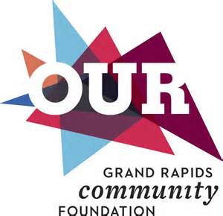
The GRCF’s website was a great starting point, and upon perusing the site’s contents for no more than a minute visitors are immediately drawn to the logo and its bright colors. Although the word “Our” helps drive home the idea of a unified community for all, it is the choice of color that provides a greater meaning. The colors shown (orange, light blue, dark blue, purple, and red) all have specific meanings that are relatable to the greater message and purpose of the organization. Orange symbolizes enthusiasm, fascination, determination, and encouragement. Light blue represents tranquility, harmony, and understanding. Dark blue invokes thoughts of integrity and wisdom. Among other meanings, purple is often translated to ambition and dignity. Red carries the connotation of leadership, courage, and friendship (color-wheel-pro.com). On their own each of these colors fall into one of the two thematic elements found in this organization; however, it is important to note that each of these colors are overlapped and blended together. This design choice signifies that through an integrated citizenry combined with a strong desire and will, community reform will thrive. Building off the logo’s message is the site’s vision found in the about page.
When searching through the about section, one will be made keenly aware of the broad audience the GRCF is attempting to reach. Using words such as “magnetic” and “interconnected”, as well as stressing the importance of outreaching a welcoming hand, the GRCF is sending an inclusive message that invites all groups of people from the Grand Rapids area to its ranks. This message is further bolstered by a “Diversity and Inclusion Statement” that asserts the following “With intention and honesty, Grand Rapids Community Foundation offers a safe environment that values diversity and fosters inclusion. We recognize the injustice caused by racism and commit ourselves to eliminating it in all forms” (GRCF Website). After reading this statement and observing the type of language used to describe the organization’s vision, it is clear that there is no discrimination in which audience is being appealed to. Regardless of skin color or cultural makeup, the GRCF is open to citizens from all walks of life. This non-denominational approach coincides with the website’s purpose of drawing in supporters and donors who are unaware of the organization. It is essential for the GRCF to take this stance, as it would be utter hypocrisy for an organization geared towards a unified and improved community to be selective.

One final key element found in this artifact is a paragraph found on the homepage that harps on the importance of being committed to one’s community. Words such as “breathtaking”, “energizing”, and “excitement” grace this paragraph in hopes that a visitor may be filled with community pride (GRCF Website). Charged language such as this is useful in drawing in readers, and generating interest in what is being said. The smiling faces that can be seen in the tabs below only further enhance the jolting dialect, as they too contribute to the theme that being involved is an enjoyable feeling. By all accounts, this artifact presents the aforementioned themes in a welcoming manor. This method is not exclusive to the GRCF’s website, as it can be seen in advertisement as well.
After transitioning from the web to the television, I then audited a GRCF PSA that promoted inclusion and participation. While the website served the purpose of introducing the organization and its mission, this artifact focuses more on making the organization’s presence known to audiences. It does this by sending the message that through its values, work, and leadership, the GRCF promotes diversity and inclusion. The piece goes on to emphasize that for Grand Rapids to truly thrive, all citizens must be aware of their value to the community. An emphasis on non-exclusivity is also shown in the imagery used in the PSA. Starting with a mural of several races of people cultivating a field, as well as various images of the cities, the fact that every race has their place in Grand Rapids is cemented (GRCF PSA). Aside from the unifying goal of this PSA, the message that everyone can contribute to the betterment of his or her community is also present. Once again, the themes of inclusion and a sense of joy in bettering one’s community are present.
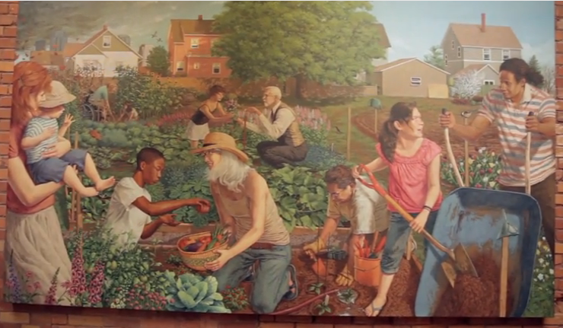

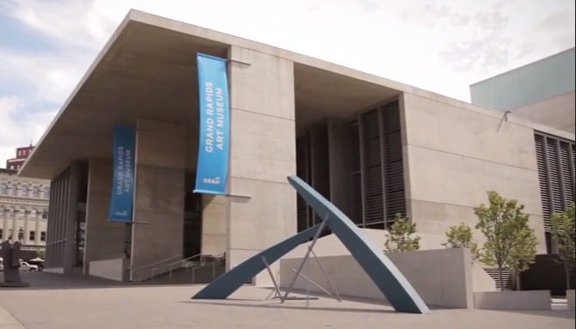
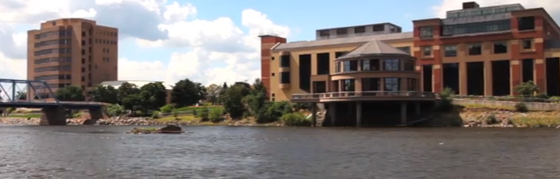
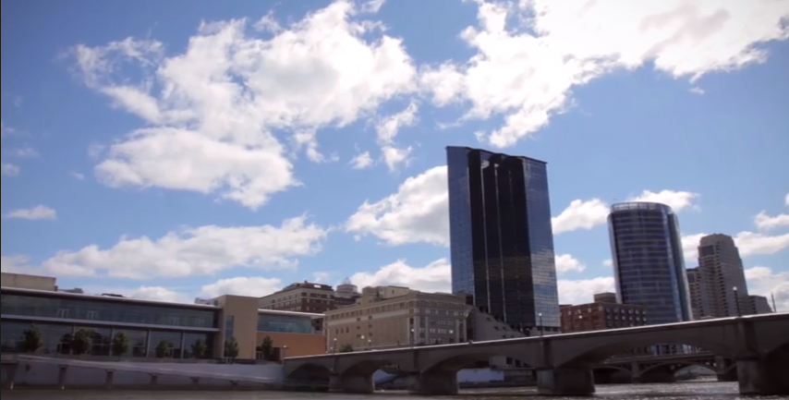

By making these claims, the GRCF is inspiring a sense of worth in their audience and dispelling fears of irrelevancy. This empowerment may cause a viewer to feel a sense of duty that drives them to go find out what they might be able to do for the GRCF, and have their voices heard. The welcoming tone and inclusive articulation used in this artifact is an ingenious way of building support, and possibly winning over those who were previously unsure of the organization. This practice of endearing itself to audiences is further used in the next artifact.
While searching for articles centered on the GRCF, I came across a press release that documented how grant money from the organization had benefitted youth employment initiatives. Specifically, the article touches on how the $354,600 donated to 11 non-profits has helped give low-income teens job experience in fields such as construction and office work (GRCF Press Release). This press release serves many purposes, at first glance it shows that the GRCF has found success and is effective; thus, the GRCF receives accolades for their efforts. Secondly, it may inspire donors to continue to provide GRCF with the funds necessary to provide this service. Finally, it may make teens or parents aware of the opportunity to receive job training and a summer paycheck at a young age. Unlike the previous artifacts, this press release is completely void of images; however, the text provided manages to promote the main themes found in the previous artifacts. The fact that the GRCF is even giving publicity towards grants that inspire interest in bettering one’s self and community is an affirmation of the second theme. Unity and inclusion is represented in a different light as this artifact is geared more towards youths being included in the community, as opposed to different races of citizens. GRCF also reaches the youth of Grand Rapids through the use of my final two artifacts.
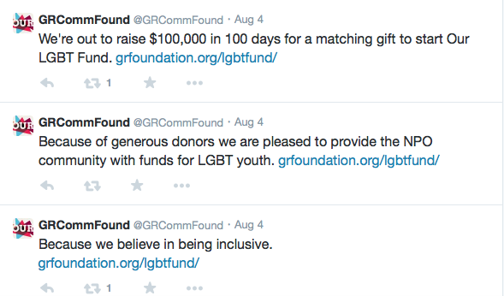
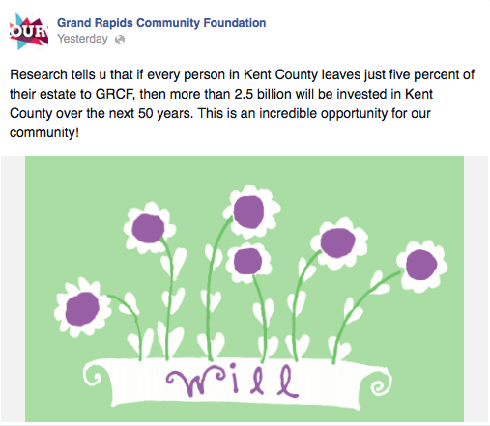
Working in tandem, the GRCF’s Twitter and Facebook page provide audiences with knowledge of beneficial information ranging from possible grant-winners, to news on other beneficial programs in the Grand Rapids community. Keeping with the practice of the artifacts preceding them, GRCF’s social media pages give off a sense of accomplishment and pride from giving back to the community as well as an inclusive audience base. This first theme is addressed in a Facebook post that claims if each citizen gave 5% of their estate to GRCF, roughly 2.5 billion dollars would be invested in Kent County (GRCF Facebook Page). Not only does this post advertise the organization, it makes the claim that every citizen matters in developing Grand Rapids. The theme of inclusion can be seen in a series of Tweets the GRCF made about raising money for an LGBT fund (GRCF Twitter Page). Not only does this post give attention to a worthy cause, but it also lets the LGBT audience know that they are welcomed and celebrated in the Grand Rapids community. Another important factor to keep in mind is that these social media pages reach out to an audience other artifacts do not. Sure the primary audience is still citizens in the Grand Rapids area; however, Twitter and Facebook are outlets often used by a younger audience. By making itself available to a younger audience, the GRCF is increasing its relevancy for future generations.
After inspecting each artifact, I have come to the conclusion that the Grand Rapids Community Foundation presents itself in a positive light. Each artifact adheres to themes of inclusiveness and a prideful donation of oneself to their community. These thematic elements fuel the GRCF’s mission of bettering Grand Rapids, and fill audience’s with a sense of familial devotion. By producing these artifacts the GRCF is transmitting the ideal that by uniting as one, citizens are striving for a brighter tomorrow. Overall, I would say that the GRCF is a worthy organization with praiseworthy aspirations and goals.
By analyzing the rhetorical meaning found in the GRCF’s artifacts, I feel that I have gained a stronger understanding as to why professional writers are so important. They can influence people to vote for a candidate solely based on one stance, or convince buyers that the new IPhone is superior to any other cellular device. Although these are impressive abilities to have, I am most fascinated by the way professional writers can unite a community. The newest product will only last so long, but instilling a sense of commitment to one’s neighbors and community is much more permanent.

Work Cited:

- Grand Rapids Community Foundation. N.p., n.d. Web. 20 Sept. 2014. <http://www.grfoundation.org>.

- Youtube. N.p., 16 Jan. 2014. Web. 20 Sept. 2014. <https://www.youtube.com/watch?v=OfH7M5XbeuY>.

- "Grand Rapids Community Foundation Opens Career." Grand Rapids Community Foundation. N.p., 7 July 2014. Web. 20 Sept. 2014. <http://www.grfoundation.org/pressreleases/20140707/Grand_Rapids_Community_Foundation_Opens_Career_Doors_for_Hundreds_of_Low-Income_Youth>.

- Twitter. N.p., Sept. 2008. Web. 20 Sept. 2014. <https://twitter.com/GRCommFound>.

- Facebook. N.p., n.d. Web. 20 Sept. 2014. <https://www.facebook.com/GRCommFound?fref=nf>.

- Color Wheel Pro. N.p., 2002. Web. 21 Sept. 2014. <http://www.color-wheel-pro.com/color-meaning.html>.

